**Analyzing Climate Change Based on World Bank Data (1990-2010)**

**Abstract**

This project focuses on investigating climate change using data obtained from world bank. 7 countries across various continents were selected and the relationship of the following factors: Co2 emission (kt), Urban population, Electric power consumption (kWh per capita) and Forest land (% of land area) on climate change were investigated. The examination of causes behind climate change revealed some relationship between the factors of study for emerging countries such as Brazil, China and India

**Chart 1**

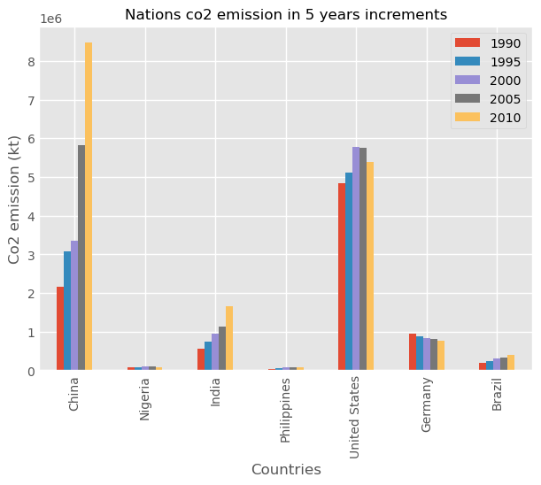

The bar graph above shows Co2 emission (kt) for 7 selected countries from year 1990 to 2010 in 5 years increments. From the chart it is evident that China is the largest emitter of C02. It recorded over 400% rise in Co2 emission in 20years. India and Brazil show an upward trend over the years in CO2 emission.

This is reflected in their trend of Urban Population as seen in chart 2. Co2 emission and Urban Migration are positively related for the countries of China, India and Brazil

**Chart 2**

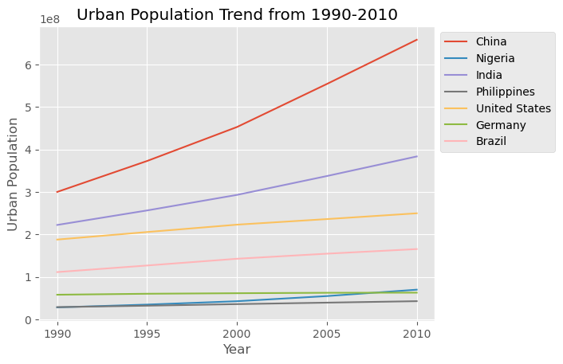

The plot gives a clear picture of the population trend for the countries over time and provides insights into the growth in Urban population size. Looking at the plot, we can see that China's population grew the highest over 200% from 300 million in 1990 to 658 million in 20 years., followed by India, the United States, and Brazil. From the Co2 Emission and Urban Population charts, it shows that China and Brazil have similar upward trends

**Chart 3**

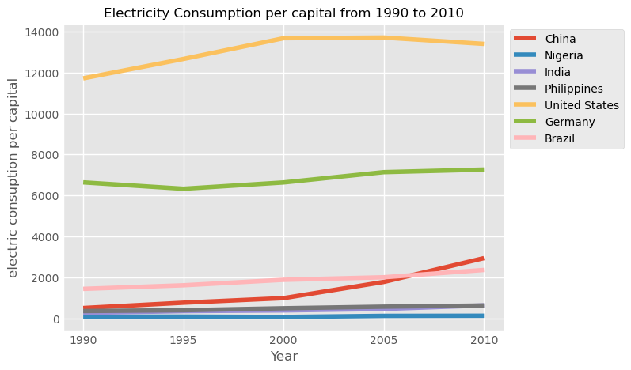

Looking at the electricity consumption data for these selected countries, we can see that China's India

n’s and h Brazil's electricity consumption has seen a steady increase since over the years. electricity consumption. Comparing this trend with other trends in the charts above, it suggests that the upward trend in electricity consumption per capital is driven by economic growth and urbanization, particularly in emerging economies such as China, India and Brazil.

**Chart 4**

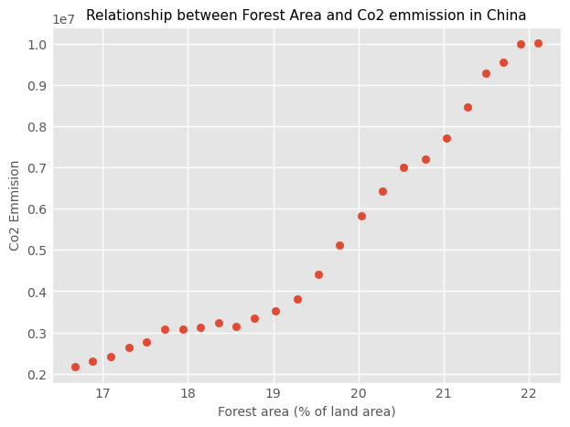

Surprising, the scatter plot in Chart 3 shows a positive relationship between forest area and population for China despite the upward trend in her co2 emission and urban growth. which are often associated with deforestation and environmental degradation. This suggest that efforts by Chinese govt to protect and expand forest areas have been successful in promoting sustainable development. However, this is not the same for Brazil who as seen a similar trend in urbanization and Co2 emission as seen in chart 4

**Chart 5**

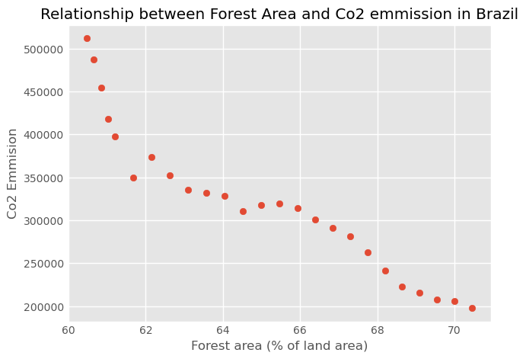

Chart 4 shows a negative relationship between forest area and Co2 emission in Brazil which suggest that the increase in Co2 emission is affecting the forest area negatively. This could be due to factors such as deforestation urbanization, and expansion and development to accommodate a growing urban population as we as seen the positive relationship between the variables

**Conclusion.**

In analyzing climate change, it can be deduced that for the country of Brazil, there is a similar trend in Co2 emission, urban migration and electricity consumption per capital. However, there seem to be a negative relationship between Co2 emission and forest area, which suggest that emission increases deforestation and increase in urbanization which results in massive land development which involves cutting down trees for development activities to cater for the growing population negatively affects the environment and climate at large